DOCUMENTATION OF SMART MOVIE THEATER MANAGEMENT

SMART MOVIE THEATER MANAGEMENT V1.0

This is a part of a smart city application. It’s main purpose is to manage movie theaters easily within the city. The operation manual to use this program is given below

At first when we run the application the Admin Login comes up. The admins are mainly the officials of different theaters.

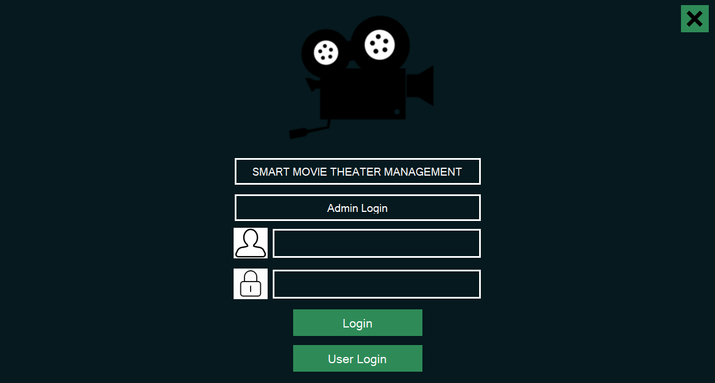

The X icon on the up right corner exits the application.

As we can see this page gives the officials, access to more controls for the theaters.

When someone gives the username and password and tap Login button the the Admin Panel Shows Up.

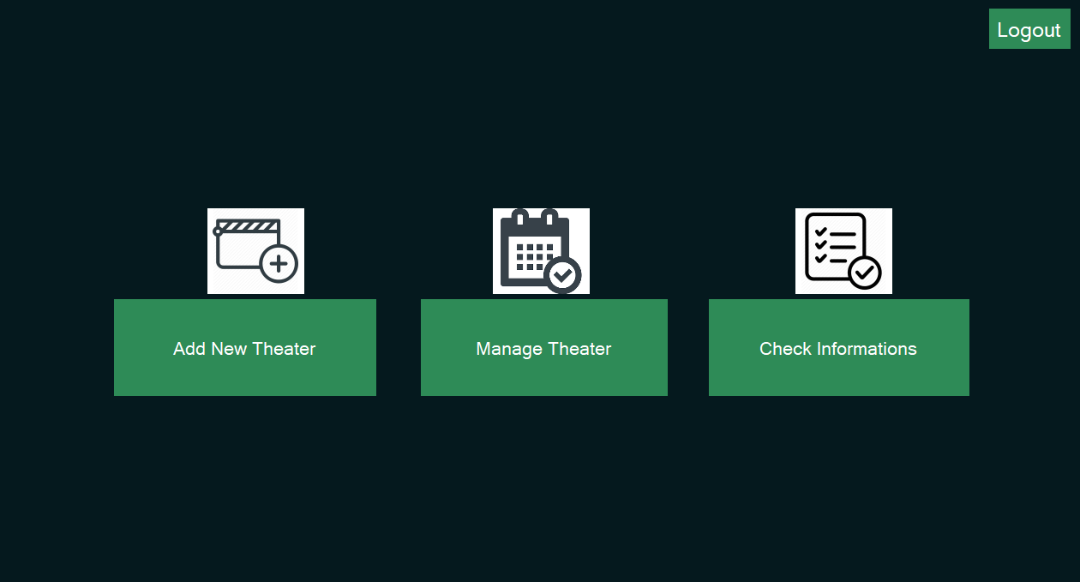

There are mainly three types of functionality for the officials.

1. They can add new theaters.
2. Manage an existing theater
3. Check user information.

The Logout button takes the admin back to the Admin Login Page.

If someone presses the Add New Theater Button Then Theater Add Window opens.

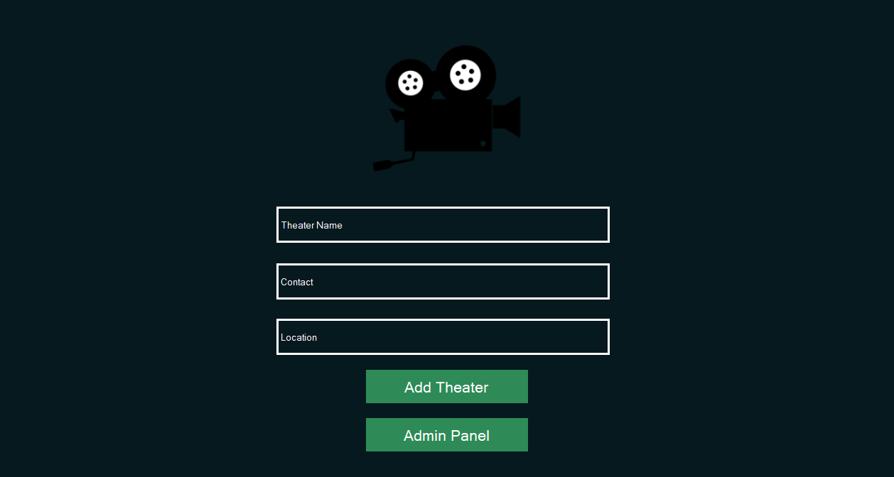

The officials can add new theaters in their database to manage it with this piece of application.

The Admin Panel button takes the admin back to the Admin Panel Window.



Now if the admin enters the Manage Theater portion this particular window appears

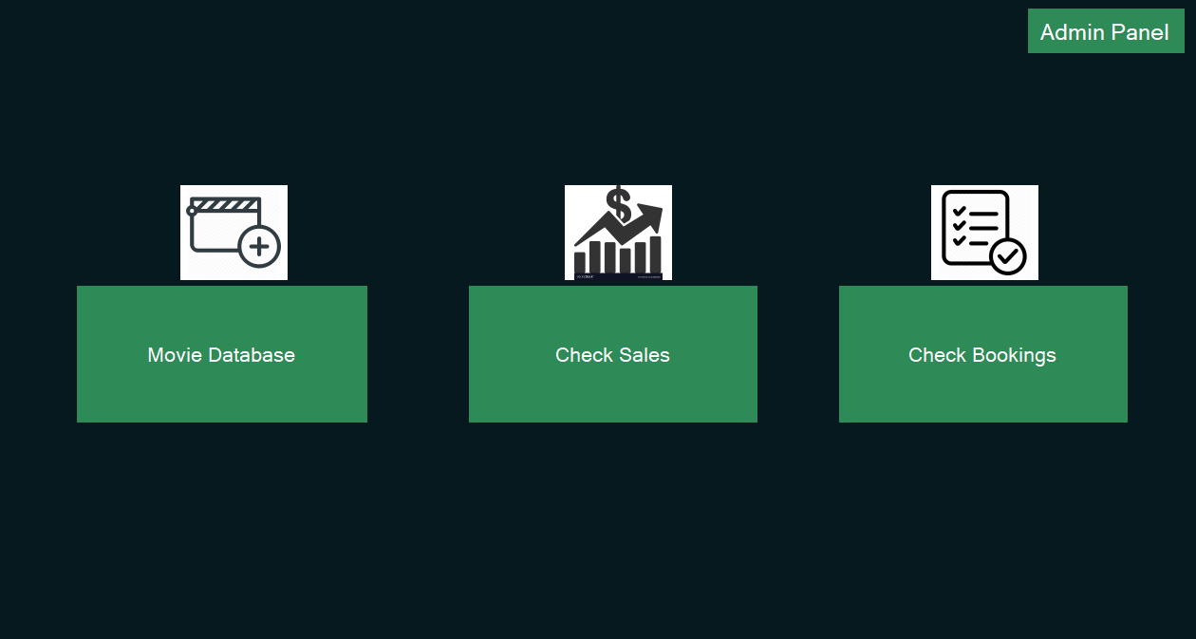

Where the admin can do three things.

1. Make changes in Movie Database.
2. Check sales of a particular theater in a particular date.
3. Check bookings of users.

The Admin Panel button takes the admin back to the Admin Panel window.

If Someone presses the Movie Database Button then this particular window appears.

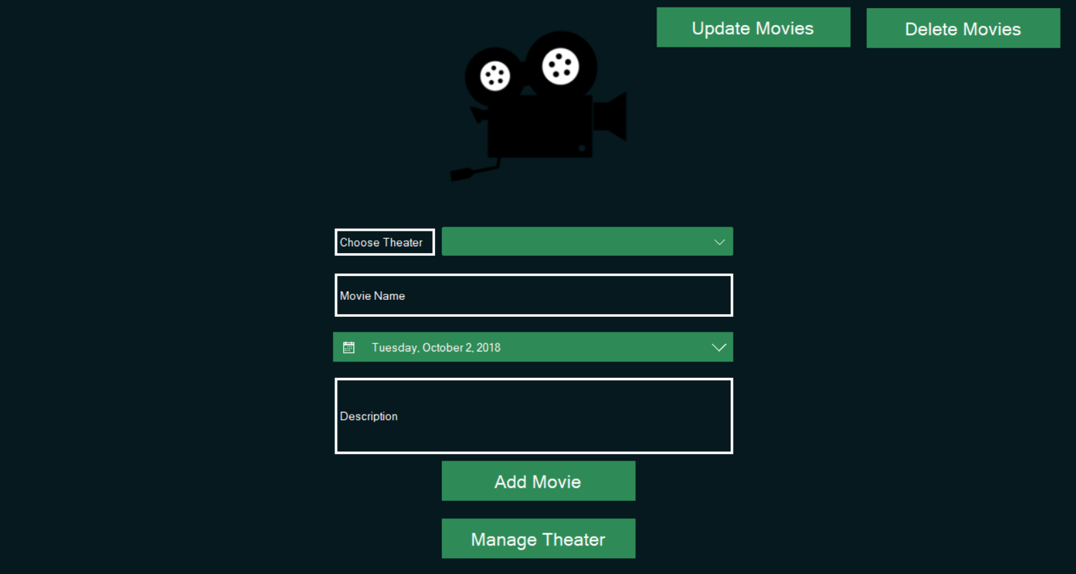

There are three kinds of function to perform.

1. Add a new movie.
2. Update an existing one.
3. Delete a movie.

The Update Movies Button takes the admin to the Update Movies window

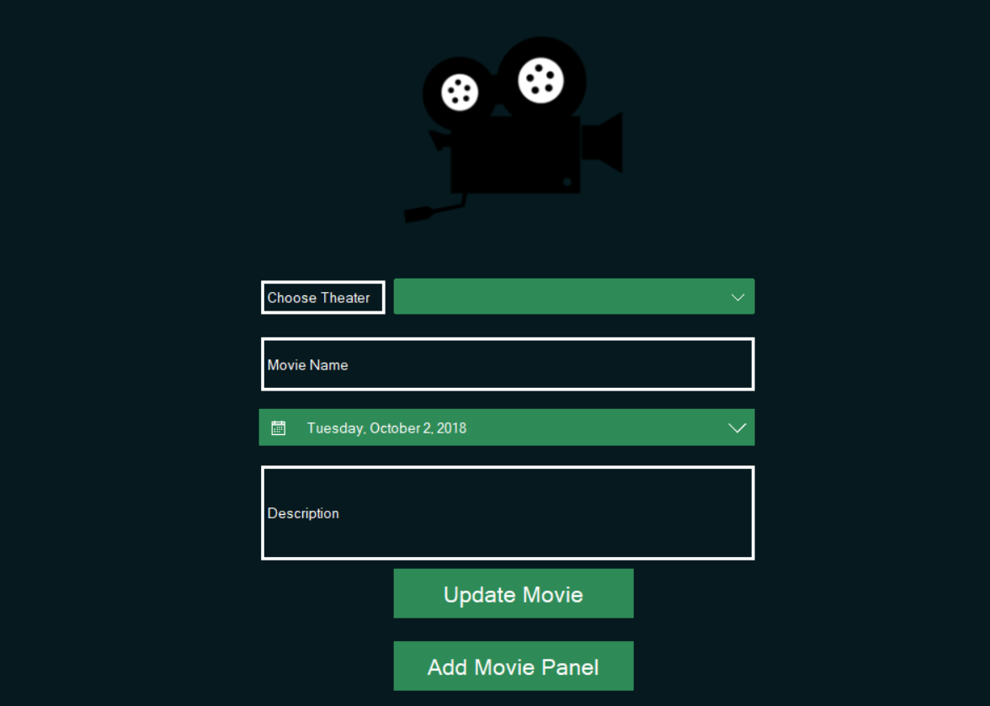

In this window a particular movie can be updated to the latest information.

The Add Movie Panel button takes the admin back to the Add Movie Panel.



The Delete Movies button takes the admin to the Delete Movies window.

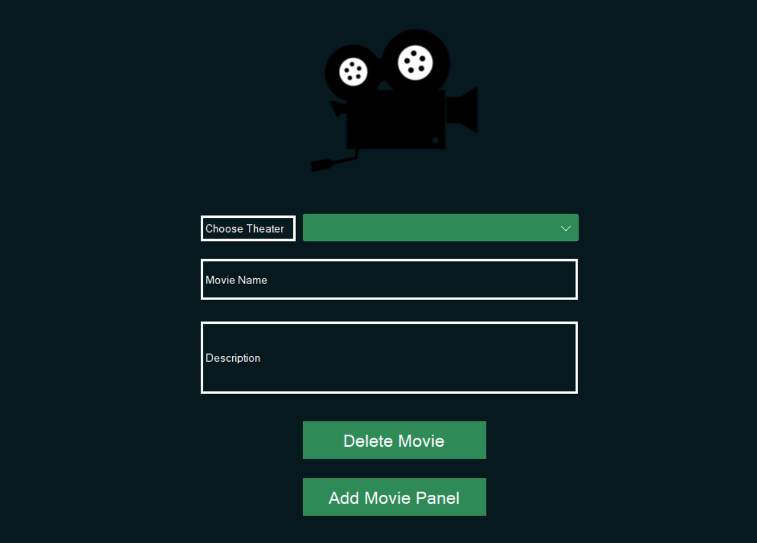

In this window an admin can delete a movie from the database. The Add Movie Panel button again takes the admin back to the Add Movie Panel Window.



The Manage Theater button takes the admin to the Manage Theater Window.



From here the admin can also check sales of a particular theater by clicking the Check Sales button.

Check Sales window appears when the Check Sales button is pressed.

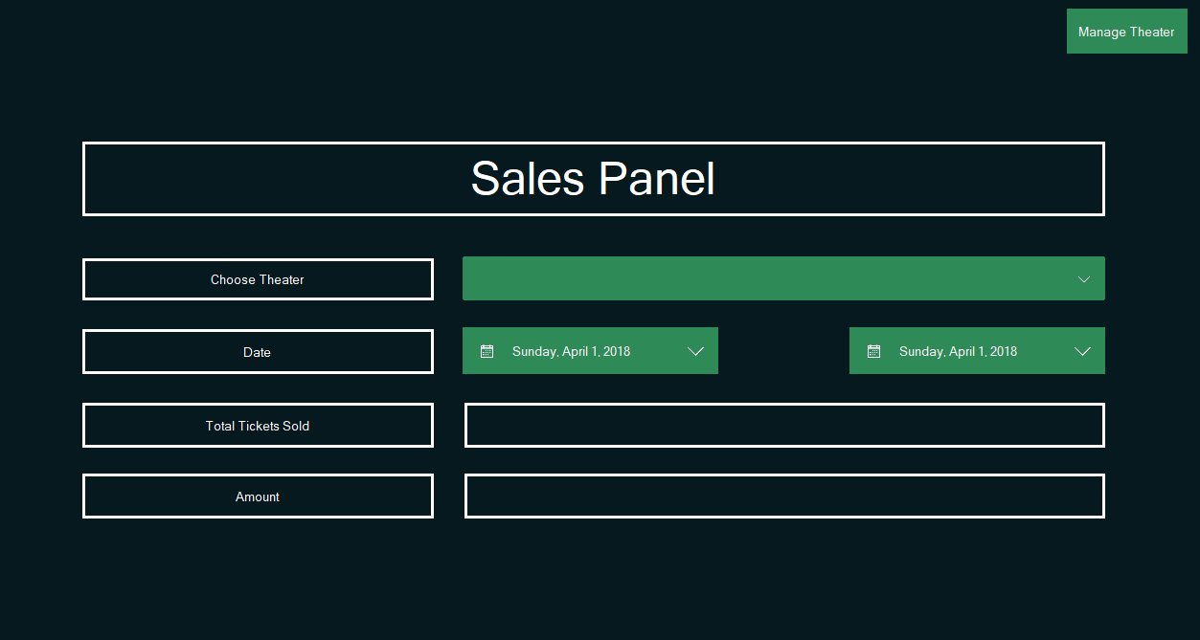

Here the admin can check sales between particular dates.

The Manage Theater button on the top right corner takes the admin back to the Manage Theater window.



The last thing here is the check bookings.

This particular button takes the admin to the Bookings Check Window

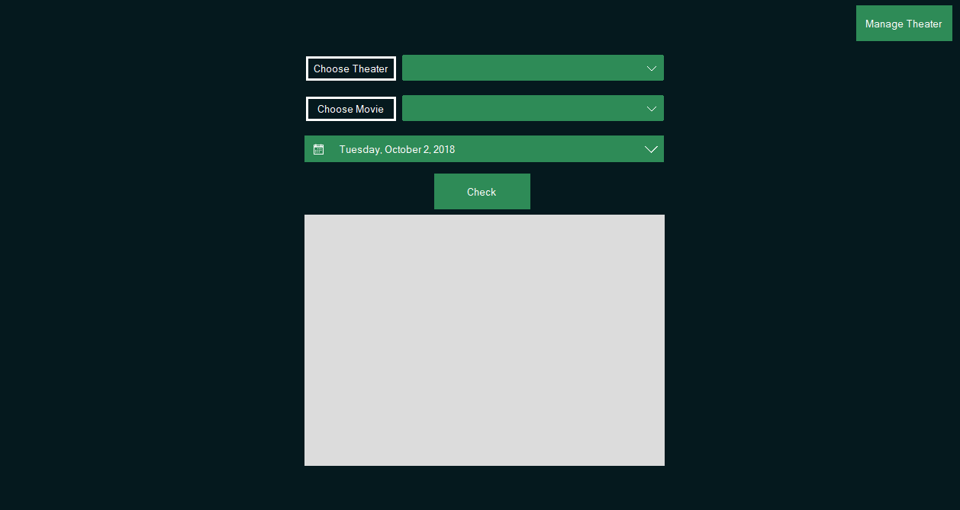

Admin can select a particular theater, movie and date to check bookings.

The Manage Theater button again takes him to Manage Theater Window.



The Admin Panel button takes him to the Admin Panel Window from here.



The admin can check user information with the Check Information Window. It appears when he presses the Check Information button.

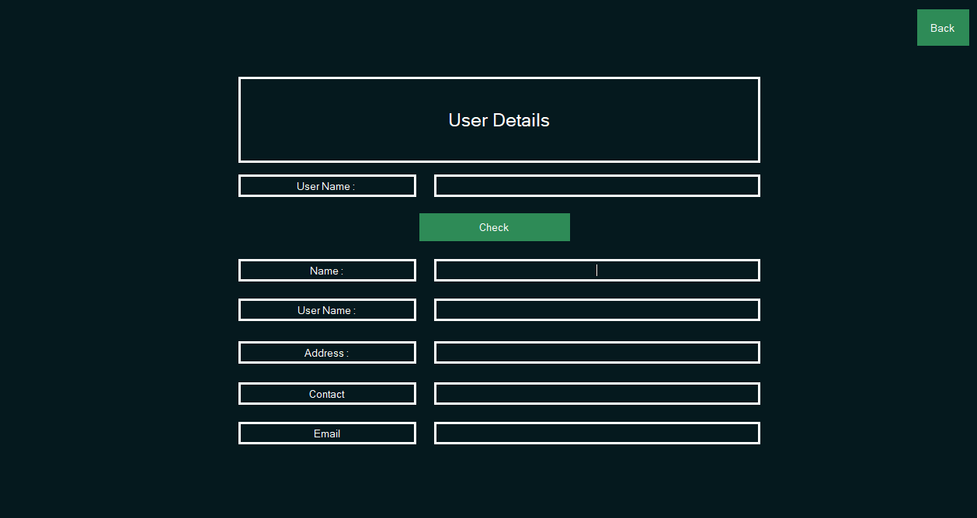

The unique User Name gives the information of the user. The Back button takes the admin back to the Admin Panel window.



The admin functionality ends here. The admin then again click the logout button to get into the Admin Login window.



If the user is not a admin. Then he/she will click the User Login button to get to the User Login window.

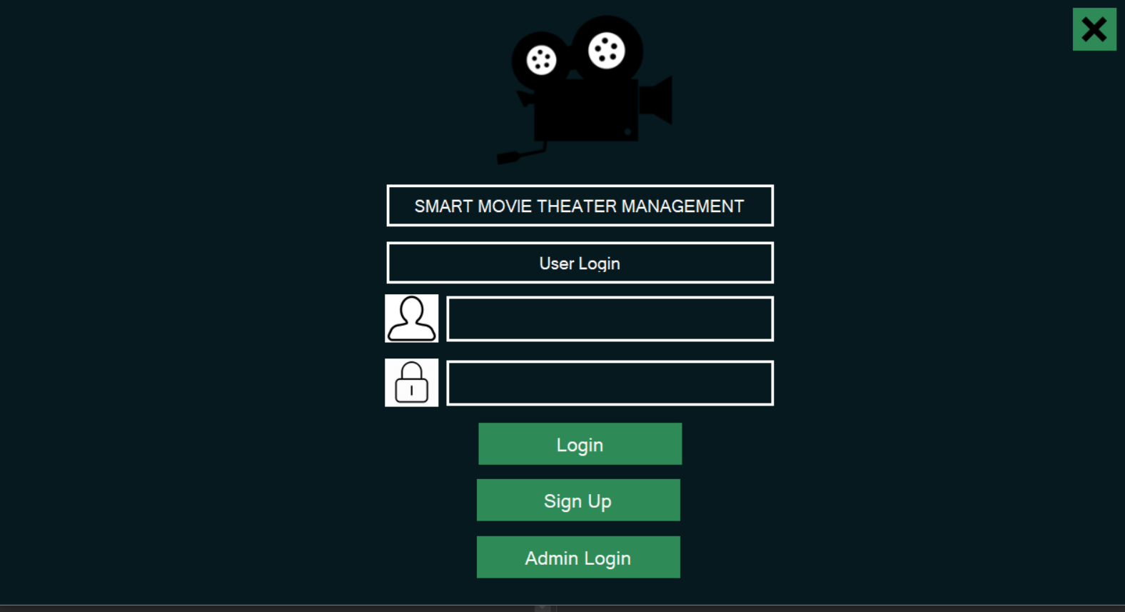

There is a X button to close the application.

The user can give the User Name and Password to get into the User Panel.

If the user is new to the system. Then they must register in the system using Sign Up button.

The Sign-Up window looks like this,

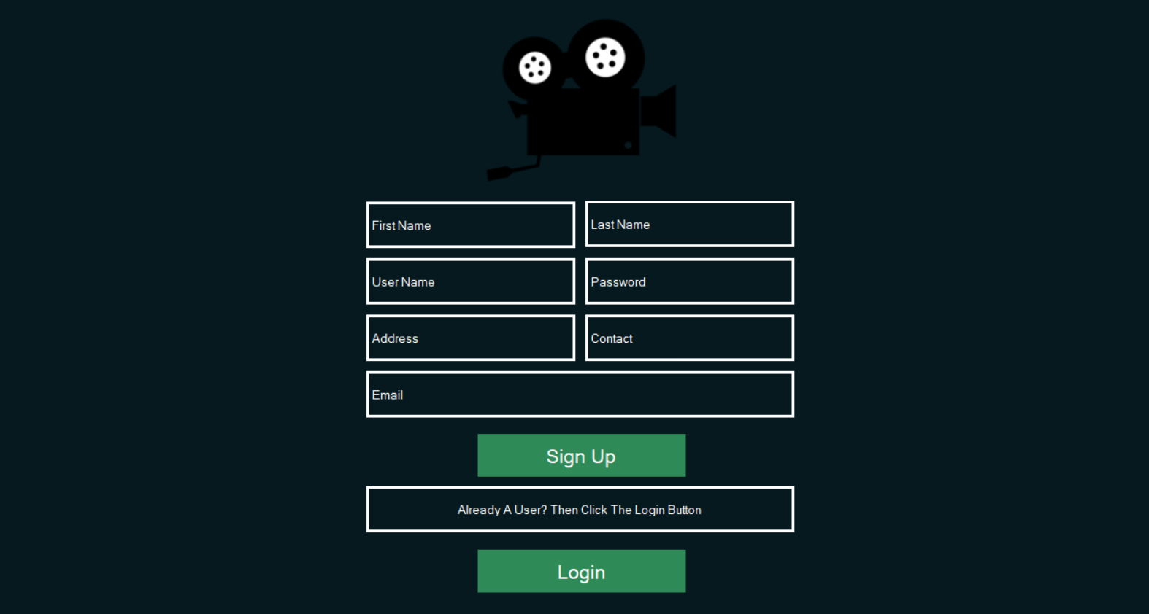

The user can register in the system with the Sign Up button after completing the required information.

The Login button takes the user to the User Login Window.



If a user login into the system with the Login button then the User Panel window appears.

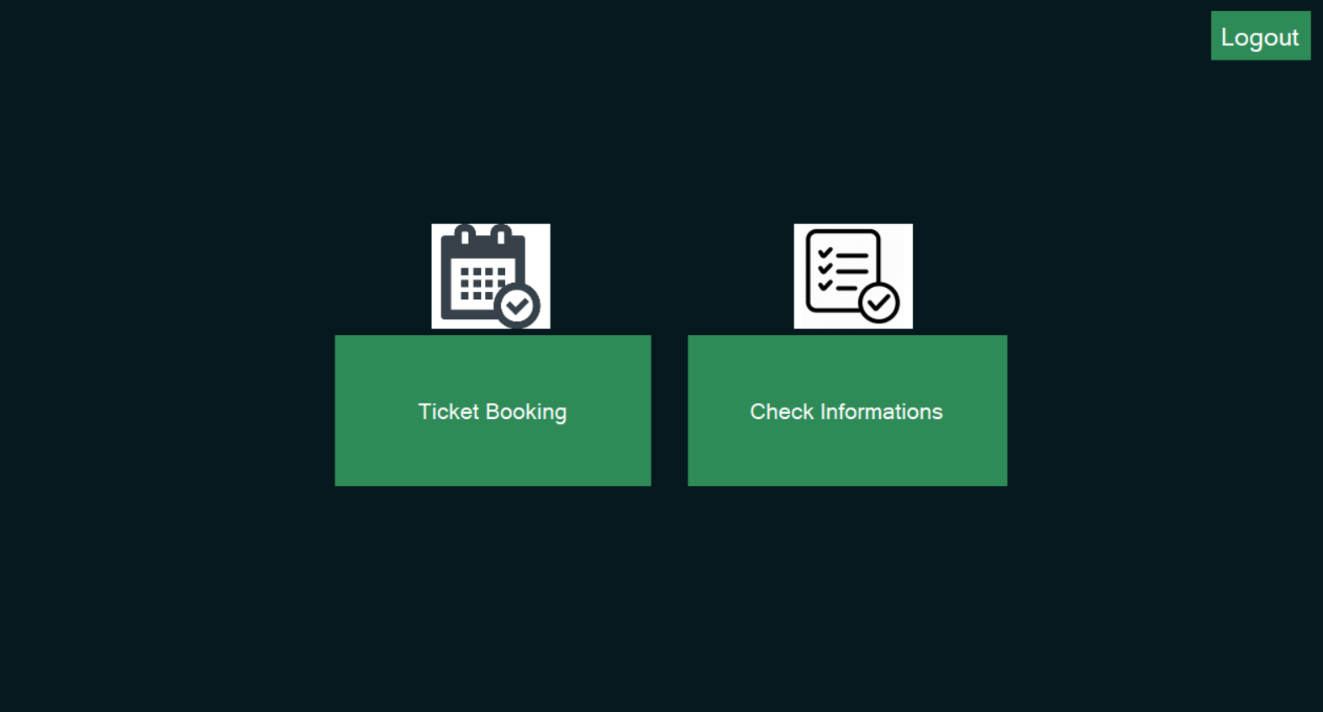

The user have two functions in his hand.

1. Booking a ticket.
2. Update his information.

If he clicks the Ticket Booking button then the Ticket Booking window appears.

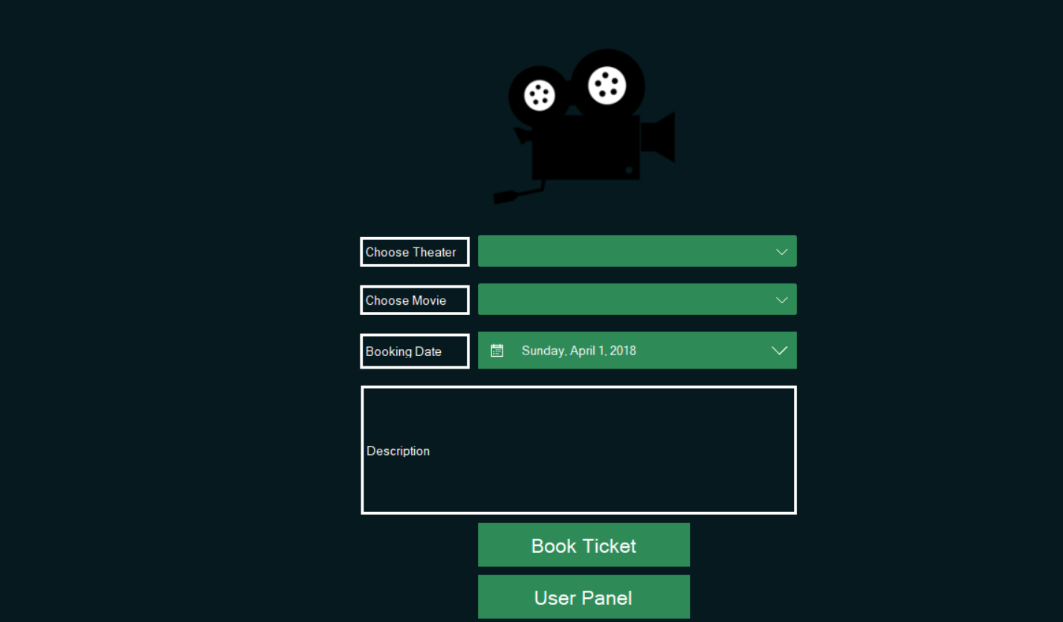

The user can choose a theater, movie and the date of booking then press the button Book Ticket to book.

The User Panel button takes the user to the User Panel window again.



The button Check Information lets the user to check his/her information and update them.

This is the Check Information window.

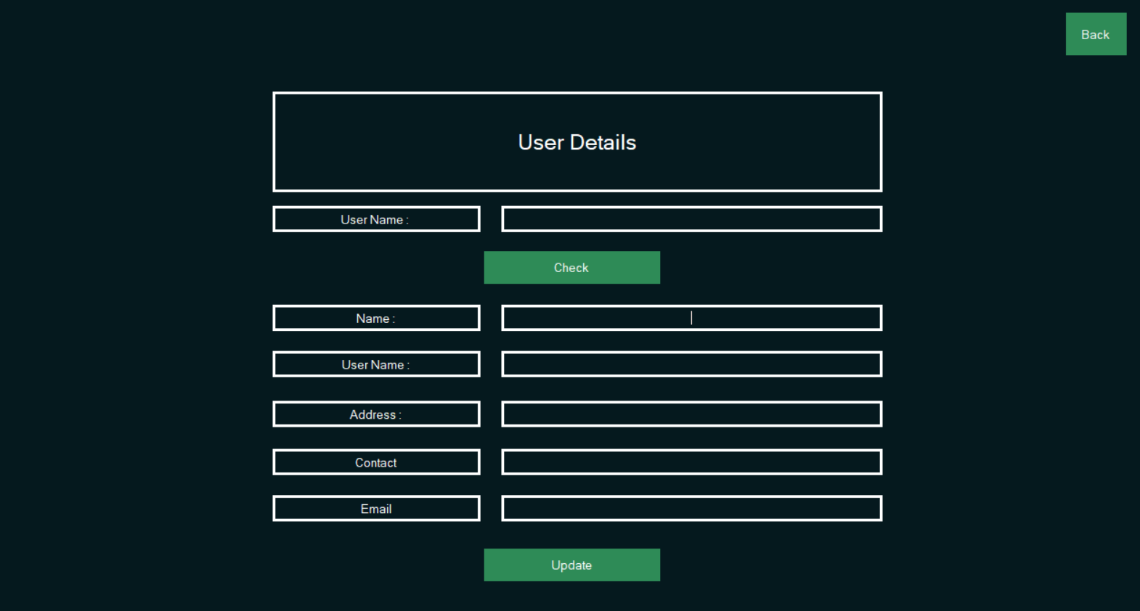

Here he/she can update and check their own information.

The Back button takes the user back to the User Panel window.



The Logout button takes the user to the User Login Page.



If the user is a admin himself and want to login again. Then he can again clock the Admin Login button to get into the Admin Login window.



This is the elaboration about how to use this application to your need.

Thank You.